**FLAME: STUDENT EXAM IDENTIFICATION AND AUTHNTICATION SYSTEM USING FINGERPRINT BASED TECHNOLOGY USER MANUAL**

**Submitted in partial fulfilment of the requirements for the award of the degree**

**Of**

**BACHELOR OF TECHNOLOGY Hons**

**In**

**INFORMATION SECURITY & ASSURANCE**

**By**

**FUNANI NDOU**

**MITCHELLE MAZHAMBE**

**NEVILLE MAHOVE**

**School of Information Sciences and Technology**

**Department of Information Security & Assurance**

**Harare Institute of Technology**

**User manual**

**System Overview**

The system is designed to pass only users verified by their fingerprint scan and block non-verified users. The system consists of two main processes for authentication, these includes identification and verification. In verification, the system compares an input fingerprint to the “enrolled” fingerprint of a specific user to determine if they are from the same finger. In identification, the system compares an input fingerprint with the prints of all enrolled users in the database to determine if the person is already known under a duplicate or false identity. After identification then the student then enters the exam room and also attendance is automatically marked.

**Procedure for running the system**

**For administrator**

1.install the application

2.install drivers for the scanner, first make sure there are no other drivers installed

3.connect the fingerprint scanner device to your laptop

4.Log in to system using the correct hard coded username and password (select login as admin)

5.the menu form opens and the admin can enrol lectures and invigilators into the system and has the privilege to perform all other operations

**For registrar**

1.install the application

2.install drivers for the scanner, first make sure there are no other drivers installed

3.connect the fingerprint scanner device to your laptop

4.Log in to system using the correct hard coded username and password (select login as registrar)

5.the menu form opens and the registrar can register students for different courses saving their details and then updating the fingerprint using a specific id

**Structure of the Manual**

The user’s manual consists of five sections: General Information, System Summary, Getting Started, Using the System, and Reporting.

General Information section explains in general terms the system and the purpose for which it is intended.

System Summary section provides a general overview of the system.

The summary outlines the uses of the system’s hardware and software requirements, system’s configuration and system’s behaviour in case of any contingencies.

Getting Started section explains how to get Access on the API. The section presents briefly system menu.

Using the System section provides a detailed description of system functions.

Reporting section describes in what way information collected by the application are presented and how to access the information

**System Summary**

The suitable environment has to be established to ensure that the implementation process runs smoothly. The following describes the software and hardware requirement for the student identification and authentication using fingerprint based technology

|  |  |
| --- | --- |
| Processor | Intel Pentium IV, 2.4GHz, or better |
| Memory |  |
| Hard disk space | @ least 40GB |
| Fingerprint scanner | Zk45000 |
|  | 256 of RAM |
|  |  |

The following tables describes the software requirements

|  |  |
| --- | --- |
| Operating system | Windows 7 or better |
| Relational database Management system | Microsoft SQL server |
| Programming languages | C# |
| System Development | Visual |
| Fingerprint driver | Zk4500SDK |

**Getting started**

**Accessing and logging in**

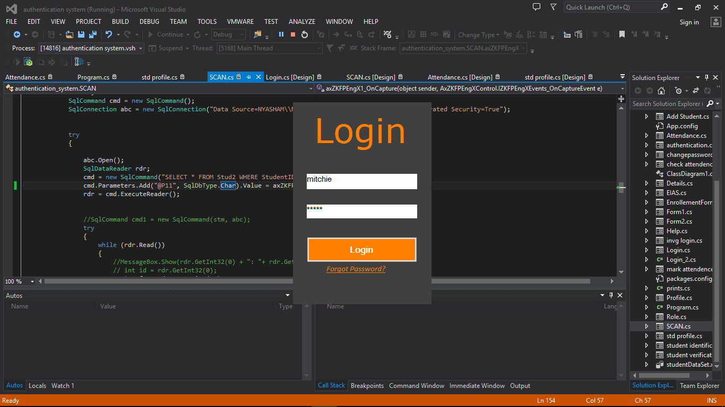

At first the user with an existing username and password in the database can get access into the system. Once the login button is pressed the system will pop the menu form or rather page. Log in to system using the correct hard coded username and password (select login as admin).

**System Menu**

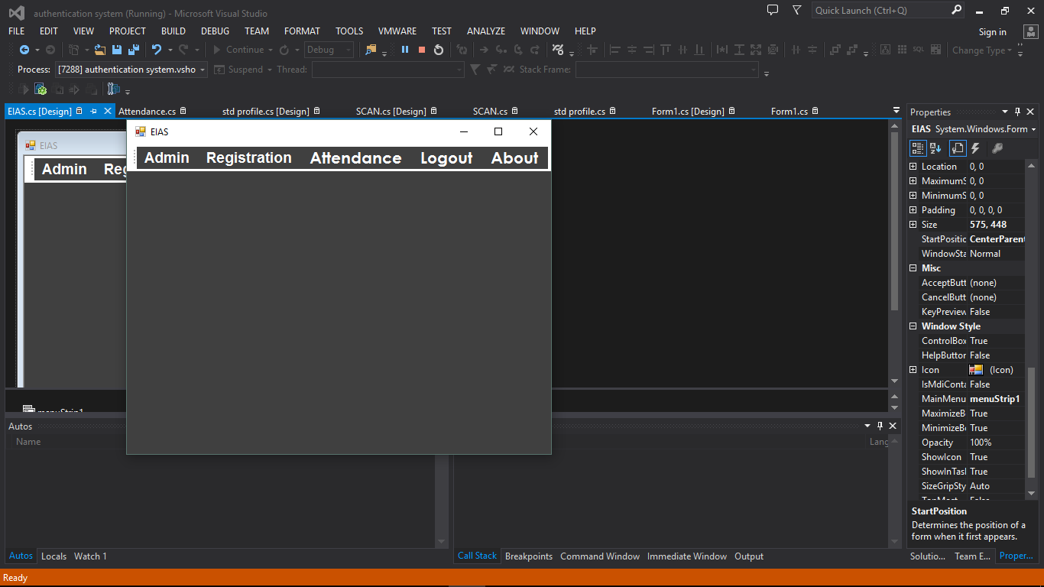

This is the main menu and it gives the user access to the registration menu and identification and identification.

Having 5 sections with drop down lists, for example on registration user can access the registration platform.

The registration area allows any user who is interested in using the student identification and authentication using fingerprint based technology to first register as a student into the database.

**Registration**

**Student Registration**



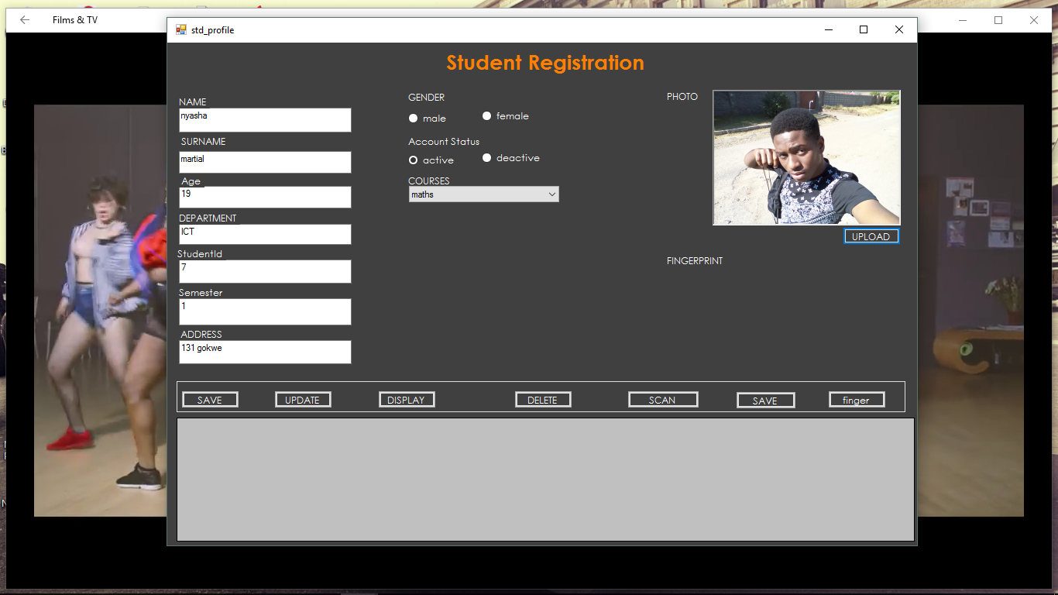

First the registrar has to enter student details into the text boxes and after filling out all textboxes he then saves the documents in the database. Registrar cannot save the student information along with the fingerprint template however the registrar after registering and scanning user student has to update the row of that student

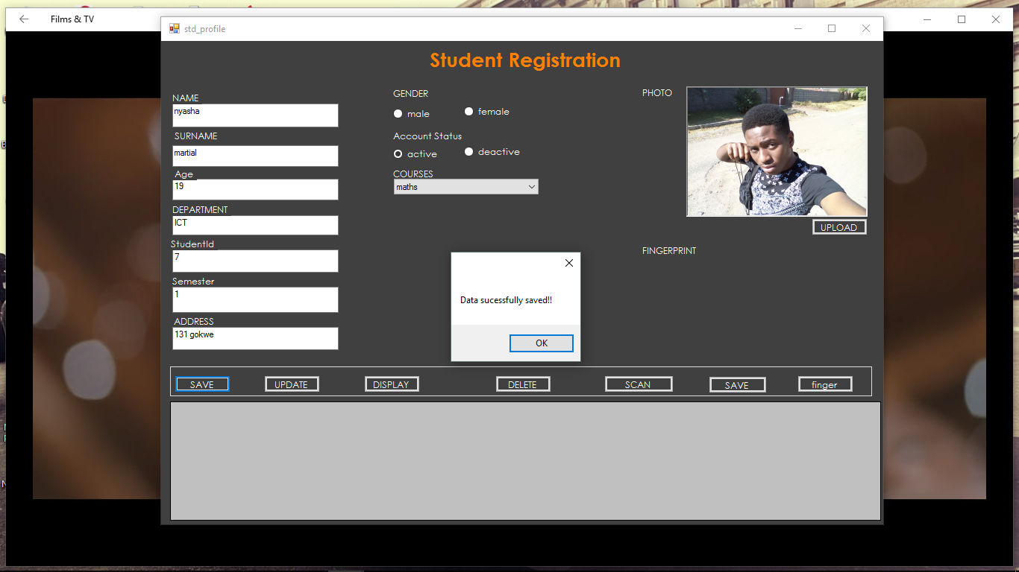

**Scanning Form**

This is the form where registrar can register a student into the database using the fingerprint.

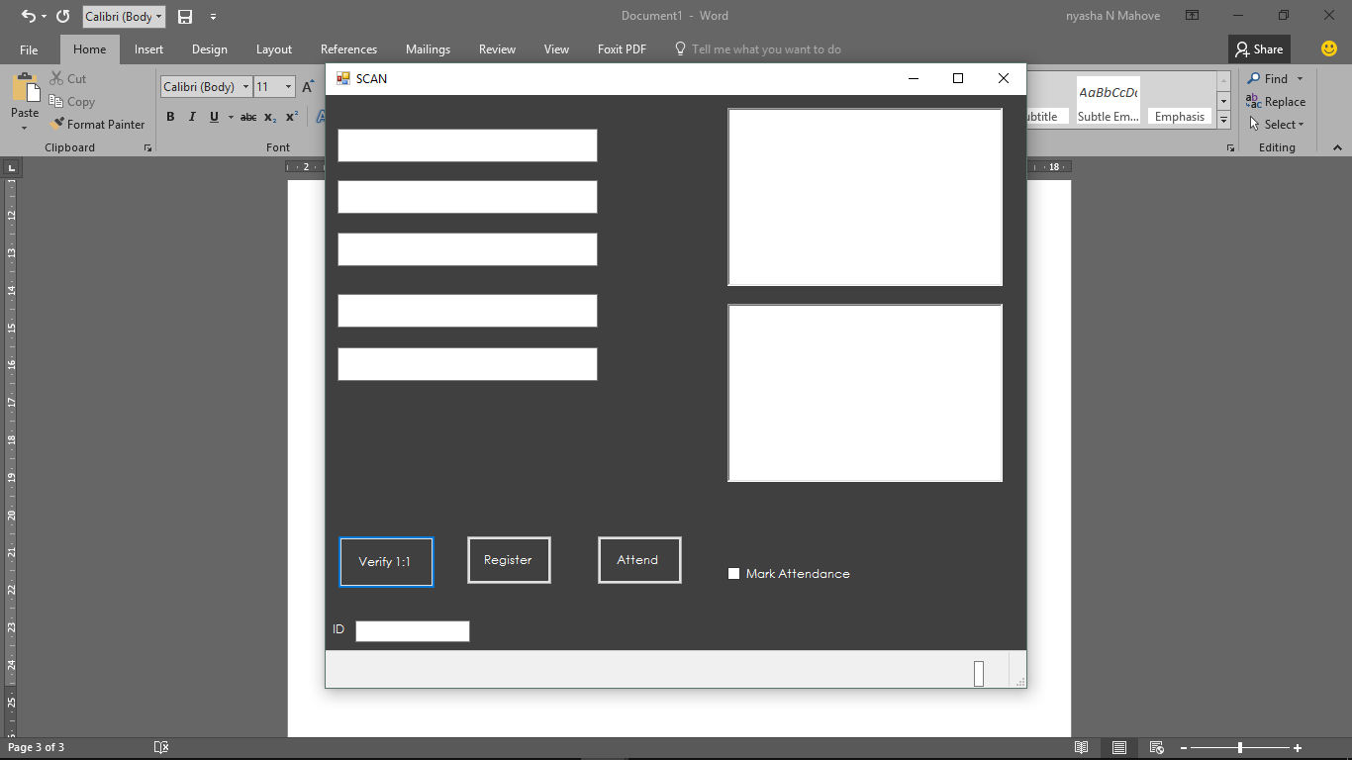

**Verification stage**

This is the stage whereby the student or candidate places his or her finger for verification and this is where the Verify 1:1 button can be used to verify if the student being scanned is registered.



For a user to view the available course work marks he has click on the button mark exam attendance

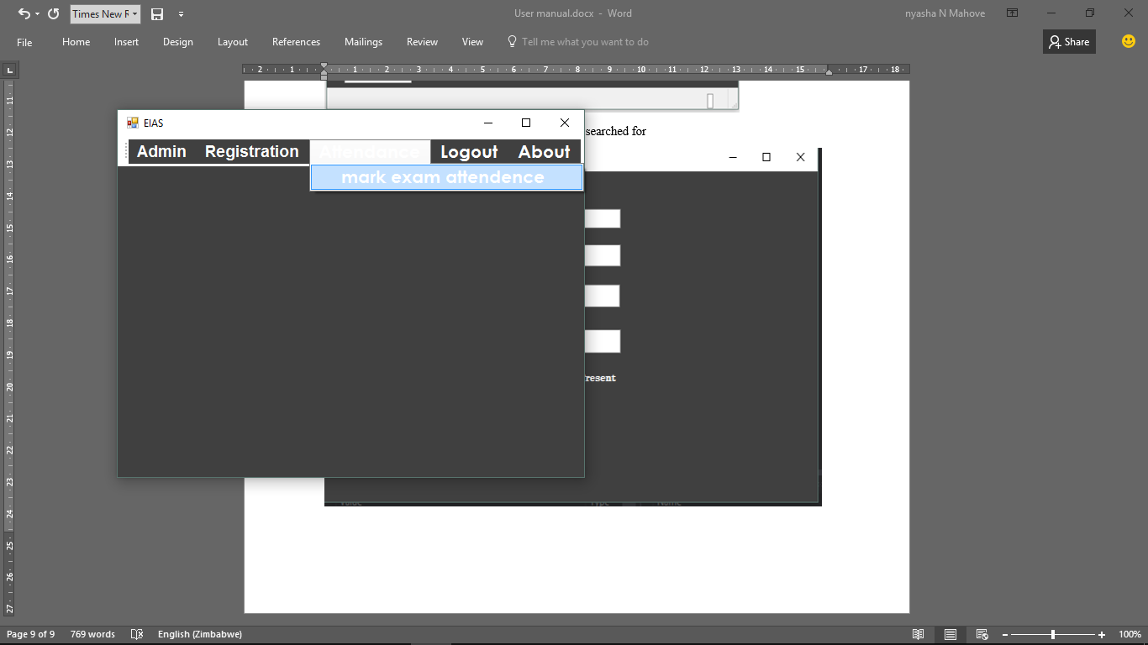

The following form shows the student who has been searched for in the database and the course work mark and attendance is displayed.

